Assignment no 10

1)Write a query that produces all pairs of salespeople who are living in the same
city. Exclude combinations of salespeople with themselves as well as duplicate
rows with the order reversed.
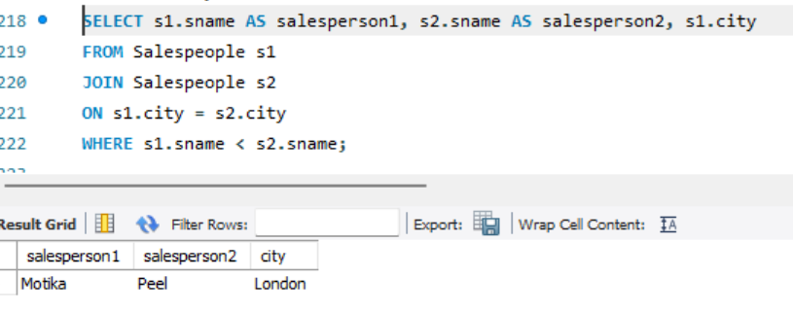
2) Write a query that produces the names and cities of all customers with the same
rating as Hoffman.
SELECT cname, city
FROM Customers
WHERE rating = (
SELECT rating
FROM Customers
WHERE cname = 'Hoffman'
);
